**LDCW6123 - FUNDAMENTALS OF DIGITAL COMPETENCE FOR PROGRAMMERS**

**GROUP PROJECT**

**Trimester 2, 2023/2024**

**Due date 24 June 2024 (Monday)**

**General information:**

|  |  |  |
| --- | --- | --- |
| Group formation | Group members shall not exceed **5** students per group and must be from the same tutorial section. | |
| Assessment | This group assignment contributes 40% to the total coursework marks. | |
| Student Learning Time | This assignment shall take 18 hours to complete. | |
| Submission requirements | Submission | Submit to respective tutor (softcopy). Submission of the report must be in pdf file.    Only group leaders will make the submission. You will follow your respective tutor submission procedure.    Name your report as: *LDCW6123 Project_student name (student id).pdf*  Example: LDCW6123 Project_Siti Fazariah Hashim (123456789).pdf |
| Cover page | Please use the attached cover page. |
| Group member’s declaration form | Please use the attached form. |
| Assessment rubrics | Included for reference. You do not need to include the rubrics into the report. |

**Mapping of assignment learning outcomes to subject learning outcomes:**

|  |  |  |
| --- | --- | --- |
| **Project Learning Outcomes**  Upon completion of this project, students should be able to: | | **Course Learning Outcomes**  Upon completion of this subject, students should be able to: |
| 1. | Design and develop an online platform that fulfills the website’s objectives. | CLO3: Build a basic interactive program with digital content. |

**Designing and Developing Website and Mobile Apps Prototypes in Collaboration with Git & GitHub**

In this group project of **5**, students will work together to design and develop a semi-functional **website** using Wix.com, create a **mobile apps prototype** using Figma and a **user manual** for that mobile apps using Canva. Each group will collaborate to complete the projects using Git and GitHub.

**Objectives:**

ü Understand the key objectives of collaboration tools and software

ü Acquire design and development skills through the utilization of Web 3.0 tools.

ü Acquire Interface prototyping skills and development through utilization intelligence tools.

ü Write a comprehensive user manual to ensure that users can navigate the mobile apps effectively.

ü Acquire the skills to collaborate online using Git and GitHub

**Guidelines:**

Select one type of project (listed below) to design and develop. Bear in mind that the features (web pages) listed for each website are essential. Students are required to include other necessary and relevant content as they deem suitable. Create a site map for the website (refer figure 1.0). For the mobile apps, it should support the nature of the chosen project (e.g.: Business, commerce, or blogs):

1. **Business**

Design a convincing narrative to educate potential customers about the enterprise, appealing to them to collaborate with you. The features on the website will include:

ü Explanation of the array of services offered.

ü Providing a comprehensive overview of the company's background (usually found on the About page).

ü Offering essential company details such as address, phone number, and email.

ü Outlining the mission statement.

2. **E-commerce**

The purpose of the website is to sell items online. The features will include:

ü Gallery with high-quality images.

ü Pages that list the products and add to cart function.

ü Wishlist of customers.

ü Customers’ order invoices.

ü Shipping tracking status.

3. **Blogs**

Blogs are developed to educate visitors about current events or specific knowledge scope, such as cooking recipes, fitness or wellness, mental health, etc. The webpages that you will include will feature:

ü Article catalogs.

ü Sample articles for each category.

ü Payment gateways for raising funds or donations.

4. **Portfolio**

Used by professionals to showcase sample works or working experiences to attract future customers. The website will have web pages that include:

ü Gallery of quality images of work samples.

ü Information about the agency or company.

ü Detailed explanation of the services and charges.

ü Contact details.

**Deliverables:**

1. Semi-functional website using (Wix.com or any online web builder)

2. Figma mobile apps prototype (Figma)

3. Mobile apps user manual (Canva)

4. Recorded Video presentation

5. Peer Evaluation form

6. Softcopy of activities using Git and GitHub (Git log)

**Submission instructions:**

1. **Group Leader** – To submit all files.

a) A pdf file consists of (Cover page, table of content, Website url Link, Figma url link & Mobile apps user manual)

*Remark: Please give access to the lecturer to view all collaborative project*

b) Recorded presentation video – (all group members must appear in the video)

c) Own peer evaluation form

d) A softcopy of the Git Log

2. **Group Member** – To submit individual peer evaluation

a) Peer evaluation form - To evaluate other members, excluding oneself.

Figure 1.0 : Sample – Website sitemap

Figure 2.0 : Wix e-commerce website

Figure 3.0 : Figma Mobile apps prototype

Figure 4.0 : Mobile apps user manual

**Reminders:**

**Plagiarism**

● Plagiarism is a serious offence.

● Plagiarism includes the following behaviors (but not limited to):

o copy another student’s work.

o fail to properly cite other people’s work or give proper credit to the original source.

o using photos, illustrations or online materials downloaded from websites without permission or consent of the original owner of the materials.

o hire or ask another individual to complete the assignment for you.

o copy too many words or ideas from one or two sources, that makes up a significant portion of your work, even with proper citations.

● The lecturer has the right not to accept submission of plagiarized or duplicated work.

**Group work**

● Each group member must actively participate in the completion of the assignment. Free riding is unethical and extremely unfair to fellow group members. **Free riders will be awarded zero mark**.

● Should any member be found not contributing to the assignment, the lecturer has the right to change the specific group’s marks to individual marks.

● Each group member is expected to keep the contact numbers and e-mail addresses of the other members of the group.

● The group leader has the responsibility to ensure that all group members play a part in the completion of the assignment. The group leader is also responsible for ensuring that all members’ names are written on the final submission.

● It is the responsibility of each group member to ensure that the final submission is complete and of an acceptable standard. Should any errors or omissions occur in the final submission, each group member is held accountable for negligence – in other words, failure to perform their responsibilities as expected.

**Assessment Rubric**

**Website & Mobile apps prototype evaluation**

|  |  |  |  |  |  |
| --- | --- | --- | --- | --- | --- |
| **Criteria** | Excellent (5) | Good (4) | Satisfactory (3) | Needs Improvement (2) | Inadequate (1) |
| **1. User Interface & Design (15 marks)** | | | | | |
| § Visual Appeal | ☐ | ☐ | ☐ | ☐ | ☐ |
| § Navigation and Layout | ☐ | ☐ | ☐ | ☐ | ☐ |
| § Consistency in Design Elements | ☐ | ☐ | ☐ | ☐ | ☐ |
| **2. Functionality & Interactivity (15 marks)** | | | | | |
| § Responsive Design | ☐ | ☐ | ☐ | ☐ | ☐ |
| § Feature Integration | ☐ | ☐ | ☐ | ☐ | ☐ |
| § Cross-browser Compatibility | ☐ | ☐ | ☐ | ☐ | ☐ |
| **3. Content Quality (15 marks)** | | | | | |
| § Relevance and Accuracy of Information | ☐ | ☐ | ☐ | ☐ | ☐ |
| § Readability and Clarity | ☐ | ☐ | ☐ | ☐ | ☐ |
| § Multimedia Integration | ☐ | ☐ | ☐ | ☐ | ☐ |
| **4. Accessibility & Inclusivity (15 marks)** | | | | | |
| § Compliance with Accessibility Standards | ☐ | ☐ | ☐ | ☐ | ☐ |
| § Inclusive Design | ☐ | ☐ | ☐ | ☐ | ☐ |
| § Overall Website & prototype performance | ☐ | ☐ | ☐ | ☐ | ☐ |
| **Total (60 marks)** | | | | | |

**Mobile apps user manual**

|  |  |  |
| --- | --- | --- |
| **Section** | **Marks** | **Evaluation Criteria** |
| Introduction | 5 | · Provide brief overview of purpose and functionality. (3 marks)  · Outline target audience for the manual. (2 marks) |
| Dashboard Overview | 5 | · Describe main components of user dashboard. (3 marks)  · Provide explanation for each feature and its purpose. (2 marks) |
| Navigation Guide | 5 | · Clearly explain website’s main navigation elements. (5 marks)  · Include visuals (screenshots or diagrams) to illustrate key features. (5 marks) |
| Functionality Guides | 10 | · Break down each major feature or service offered on the website. (5 marks)  · Provide step-by-step instructions on how to use each function. (5 marks)  · Encourage users to explore and make the most of the website’s features. (5 marks) |
| Visual Design and Branding | 5 | · Explain the visual elements of the website, such as colour schemes and logos. (5 marks) |
| **Total** | **(30 marks)** |  |

**Git & Git Hub**

|  |  |  |
| --- | --- | --- |
| **Section** | **Marks** | **Evaluation Criteria** |
| Repository Setup | 2 | · Repository setup with a clear name and README |
| Branching and commits | 3 | · Proper use of branches and clear, descriptive commit messages |
| Collaboration | 3 | · Evidence of collaboration through pull requests and discussion |
| Code quality & Documentation | 2 | · Consistent code formatting and readability.  · Clear documentation for setup, usage, and contribution guidelines. |
| **TOTAL** | **(10 marks)** |  |

**PROJECT COVER**

|  |  |
| --- | --- |
|  | **LDCW6123 FUNDAMENTALS OF DIGITAL COMPETENCE FOR PROGRAMMERS**  Trimester 2, 2023/2024 |

**GROUP PROJECT**

**Lecturer : ___________________**

**Group: ___________**

*Prepared by:*

|  |  |  |
| --- | --- | --- |
| **Student ID** | **Student Name** | **Phone number** |
|  |  |  |
|  |  |  |
|  |  |  |
|  |  |  |
|  |  |  |

**Declaration by group leader**

I hereby declare that all group members’ names are correctly included in the above section. I hold a copy of this assignment which I can produce if the original is lost or damaged. I certify that no part of this assignment has been copied from any other student’s work or from any other source except where due acknowledgement is made in the assignment.

Group leader’s signature : _____________________________

Group leader’s name : _____________________________

Group leader’s student ID : _____________________________

Date : _____________________________

**Group member declaration**

*(Each group member, including the* ***group leader****, must individually fill up and submit this form)*

Group member’s name : ____________________________

For the purpose of completing this assignment, I have performed the following tasks (please list):

*I hereby declare that I have assessed this submission and I take full responsibility should there be any inaccuracies, incompleteness, omissions, delays or non-submission.*

Group member’s signature : ________________________________

Group member’s name : ________________________________

Group member’s ID : ________________________________

Group member’s tel. no. : ________________________________

Group member’s email : ________________________________

Date : ________________________________

**CONTENT PAGE NO.**

# 

# 1. WEBSITE URL LINK

# 2. MOBILE APPS URL LINK

# 

# 

# 3. MOBILE APPS USER MANUAL

## Introduction

The mobile application is designed in such a way that will enable users to be able to browse through products being offered and make purchases easily. For instance, when selecting options in use of a mobile something as scrolling to the right it is easy to access more of the options. Furthermore, users can also make a purchase from a specific mobile or its price by simply clicking on it, making the buying process quite easy. The navigation of the application is also designed to make users explore other similar products by simply pointing to images like the demonstration of an extensive range of headphones, while at the same time availing to them an opportunity to realize that there are other products in existence.

On the main page, the app will list out products that are currently on sale, providing users with an overview that includes the product name, price, and a picture. This feature allows users to quickly browse through discounted items at a glance, making it easier for them to spot attractive deals and make informed purchasing decisions. For instance, a user looking for a new mobile phone can instantly see the options available on sale, compare prices, and view product images, all without having to navigate through multiple pages. This streamlined approach enhances the shopping experience by saving time and simplifying the decision-making process.

Managing shopping is convenient, as users have the option to either add items to their cart or proceed directly to purchase. They can easily view their cart to review items and proceed to checkout, making the purchasing process smooth and efficient. After making a purchase, users can effortlessly navigate back to browse more products, ensuring a continuous and engaging shopping experience.

Access to support is made straightforward, with users able to reach the help center directly by clicking a prominently displayed button on the screen. This ensures that assistance is always just a click away. The FAQ section allows users to add their questions and receive direct answers, enhancing the support experience.

The target audience for the manual includes new users and existing users who need guidance on navigating and utilizing the app’s features effectively. For new users, the manual serves as an essential guide to understanding the app’s functionalities. For example, a first-time user might be unsure how to add items to their cart or how to find the help center. The manual provides clear instructions and examples, helping them become familiar with the app quickly. This reduces the learning curve and enhances their overall experience, making them more likely to continue using the app.

For existing users, the manual acts as a quick reference to understand new features or troubleshoot any issues they may encounter. An example would be a regular user wanting to know how to directly proceed to purchase without adding an item to the cart first. The manual provides detailed information on this feature, ensuring that even seasoned users can take full advantage of the app’s capabilities. This continuous support and information help maintain user satisfaction and loyalty.

## Dashboard Overview

The dashboard of our mobile app is meticulously designed to ensure a seamless and user-friendly shopping experience, providing easy access to essential features and functionalities. Below, we outline the main components of the user dashboard, explaining each feature and its purpose.

The login button is prominently displayed, allowing users to quickly access their personal accounts. This feature ensures that users can log in to view order history, manage preferences, and access personalized features. By logging in, users benefit from enhanced security and a tailored shopping experience.

The wishlist feature is a convenient tool for users to save products they are interested in for future reference. It allows users to keep track of items they might want to purchase later, making it easier to find and buy these products when they are ready. This feature is particularly useful for users who like to compare products before making a decision.

Our shopping cart icon provides a quick view of the items users have added for purchase. This feature facilitates the purchasing process by allowing users to review, modify, and proceed to checkout with the items they intend to buy. It ensures a smooth and organized shopping experience, making the journey from selection to purchase as effortless as possible.

The search bar is a powerful tool that enables users to find specific digital products by entering keywords or product names. This feature helps users quickly locate the products they are looking for, saving time and improving the efficiency of their shopping process. A well-functioning search bar is essential for enhancing user satisfaction, particularly in an extensive digital product catalog.

The promotion details with poster section displays current promotions and offers, accompanied by visually appealing posters. This feature informs users about special deals and discounts, encouraging them to take advantage of promotions and make purchases. By highlighting promotions, we aim to enhance user engagement and boost sales.

Our store location feature provides information about the physical store's address and directions. This feature is valuable for users who prefer in-person shopping or need to visit for customer support. By offering clear information on store locations, we add convenience and enhance the overall user experience.

The contact section offers various ways for users to get in touch with customer support, including phone numbers, email addresses, and a contact form. This feature ensures that users can easily reach out for assistance, resolve issues, or ask questions, thereby improving customer service and satisfaction.

Lastly, the help center is a comprehensive resource that offers FAQs, troubleshooting guides, and other support materials. This feature provides users with the information they need to solve common problems and understand how to use the app's features. By offering a robust self-service option, we help users find solutions quickly, reducing the need for direct customer support.

## Navigation Guide

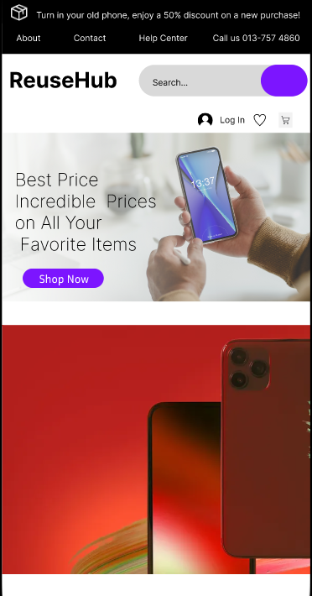

The inclusion of links to "About," "Contact," and "Help Center" in the header ensures easy access to essential information and support services. Users can learn more about our brand, reach out for assistance, or find answers to common queries directly from any page on the website.

Located prominently at the beginning of the navigation bar, the shop name serves as a direct link back to the main page or homepage of our website. It reinforces our brand identity and provides users with a quick way to return to the starting point of their browsing journey.

The search bar is a powerful tool that allows users to find specific products quickly and efficiently by entering keywords or product names. It enhances usability by enabling users to navigate directly to the items they are interested in, saving time and improving overall satisfaction.

The login button provides access to user accounts, allowing registered users to log in securely. By logging in, users can access personalized features such as order history, saved preferences, and account settings. This enhances the shopping experience by tailoring content and recommendations based on individual preferences.

The wishlist feature enables users to save products they are interested in for future reference. It serves as a convenient way for users to bookmark items they intend to purchase or compare later. This feature encourages repeat visits and facilitates informed decision-making during the shopping process.

The shopping cart icon provides a real-time view of items users have added for purchase. It allows users to review their selected items, adjust quantities, and proceed to checkout seamlessly. The shopping cart feature enhances user convenience by summarizing potential purchases and facilitating the checkout process with minimal effort.

The navigation bar offers direct access to key sections of our website, including product categories, account management, and customer support. This streamlined approach ensures that users can navigate between pages quickly and effortlessly.

## Functionality Guides



At the first page, we click on the “Shop Now” button, then we will go to product page.

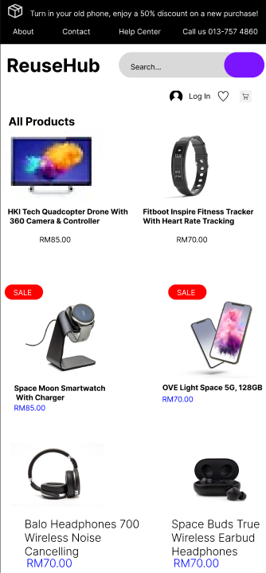

Our product page is meticulously crafted to offer users a comprehensive view of all available items in our store. Each product listing is accompanied by high-quality images that showcase the item from various angles, allowing users to click and zoom for closer inspection. These visuals provide a realistic representation, helping users to make informed decisions about their purchases. Alongside the images, product names are prominently displayed with concise descriptions highlighting key features, dimensions, materials, and usage instructions. This ensures that users have a clear understanding of what each product offers before making a choice.

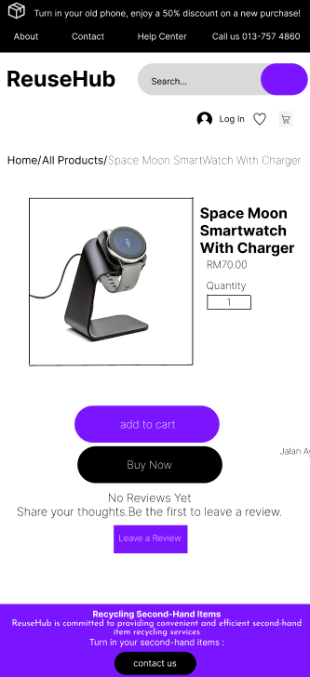

When a user clicks on a product from the product page, they are directed to the product details page, where they can delve deeper into specific item information and make purchase decisions. At this stage, users have the option to adjust the quantity of the product they wish to purchase directly on the page. A straightforward "Buy Now" button allows users to bypass adding items to the cart and proceed directly to the checkout process, streamlining the purchase journey for those ready to make an immediate purchase decision.

In addition to facilitating purchases, the product details page serves as a hub for user engagement and informed decision-making. Users can explore and read reviews left by other customers who have purchased the same product. These reviews provide valuable insights into the product's quality, functionality, and overall user experience. Star ratings accompany each review, offering a quick visual reference for product satisfaction levels.

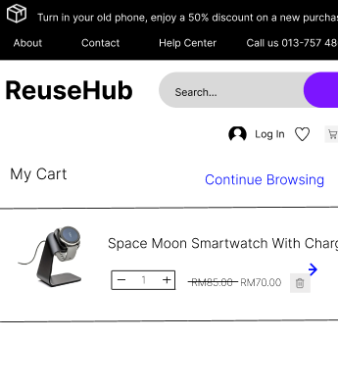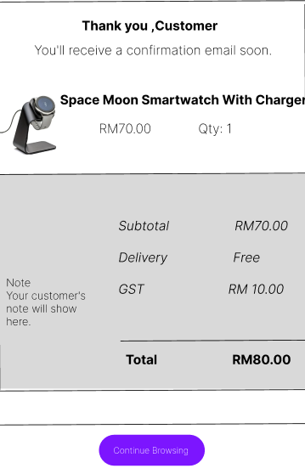

Once users have added items to their shopping cart, they can conveniently manage their selections before proceeding to checkout. The shopping cart serves as a centralized hub where users can review all items they have added for purchase. Each item is listed with details such as product name, price, selected quantity, and subtotal, providing a clear overview of their shopping selections. Users have the flexibility to either proceed directly to checkout or continue browsing to add more items to their cart.

Within the shopping cart interface, users have several options to customize their shopping experience. They can easily remove any unwanted items by clicking on the "Remove" button next to each product listing. Alternatively, users can adjust the quantity of each product directly within the cart by using the quantity input field and updating it accordingly. This flexibility allows users to refine their order and ensure they are purchasing the exact quantities they desire.

When users are ready to proceed with their purchase, they can initiate the checkout process by clicking on the arrow or "Proceed to Checkout" button located conveniently on the right side of the interface. This action directs users to the checkout page, and there will display the shipping information, select payment methods, and review their order details before completing the transaction. The checkout process is designed to be straightforward and user-friendly, guiding users step-by-step through the finalization of their purchase.

Overall, the shopping cart feature on our website enhances user convenience and control over their shopping experience. Whether users are making final adjustments to their order, exploring additional items, or ready to complete their purchase, the shopping cart provides a seamless and efficient platform to manage and finalize transactions. Explore our shopping cart functionality to streamline your shopping journey and enjoy a hassle-free checkout process for all your favorite products.

## Visual Design and Brandings

The visual elements of our mobile app are meticulously designed to create a cohesive and visually appealing user experience. The use of colour schemes and logos plays a significant role in defining the app's aesthetic and functionality.

Our app primarily utilizes three colours: black, white, and purple, each serving distinct purposes to enhance the user interface and experience. Black is used for the navigation bar and information lists, providing a strong contrast against the white background. This choice makes these elements easily readable and visually distinct, guiding users effortlessly through the app. White, employed as the background colour, creates a clean and uncluttered look. It provides a neutral canvas that highlights content and other design elements, reducing visual fatigue and enhancing readability.

Purple is reserved for action buttons such as "Check Out," "Search," "Shop Now," and "Add to Cart." The vibrant purple colour draws users' attention and prompts them to take specific actions. This strategic use of colour makes the buttons easily identifiable and encourages interaction, thereby improving the overall usability and functionality of the app.

Our app features a distinctive logo that embodies our brand identity. The logo is a simple yet memorable design: a box with a black background and white lines. This minimalist design seamlessly fits with our overall colour scheme while conveying a deeper meaning related to our brand's mission. The black background provides a solid foundation, while the white lines suggest the continuous cycle of reuse and renewal. This symbolism emphasizes our commitment to recycling and sustainability, highlighting the importance of eco-friendly practices in our operations.

The combination of these visual elements—colour schemes and logos—creates a harmonious and user-friendly interface. The thoughtful use of black, white, and purple enhances the app's aesthetics and improves navigation and usability. By maintaining a consistent and appealing visual identity, we ensure that users have a pleasant and engaging experience while interacting with our app. The logo's symbolism aligns with our values, reinforcing our dedication to sustainability and the recycling of second-hand products. This cohesive design philosophy not only makes the app visually appealing but also communicates our brand's core principles effectively to the users.

## User manual(canva)

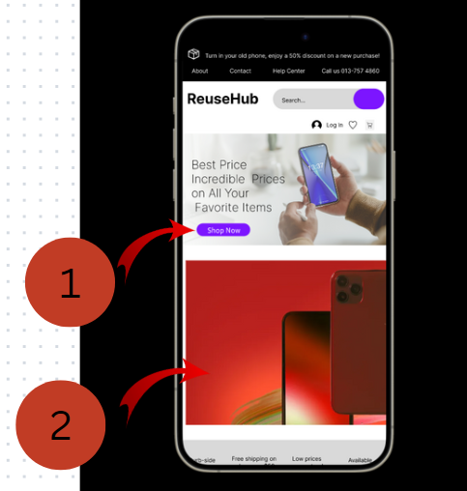

1. Users can conveniently shop now by simply pressing this button to explore our latest offerings.

2. Users are encouraged to click on this image to discover our comprehensive selection of mobile phones.

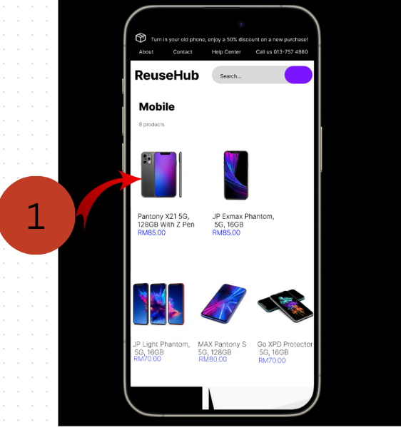

1.Users can easily navigate by scrolling to the right to explore more mobile options or they can initiate a purchase by clicking on the desired mobile.

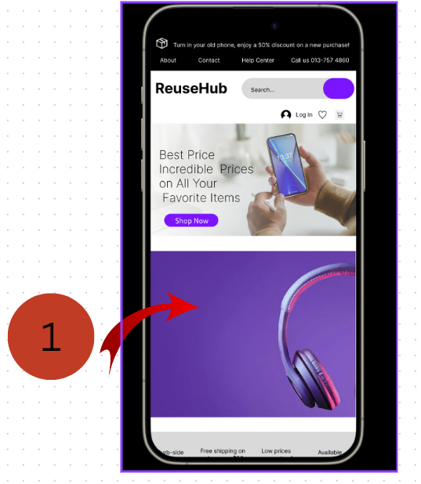

1.Users are encouraged to click on this image to discover our comprehensive selection of headphones.

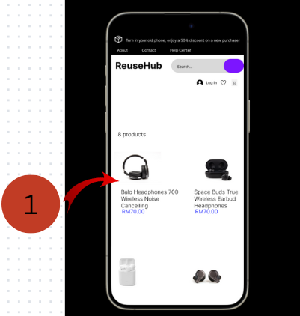

1.Users can easily navigate by scrolling to the right to explore more mobile options or they can initiate a purchase by clicking on the desired mobile.

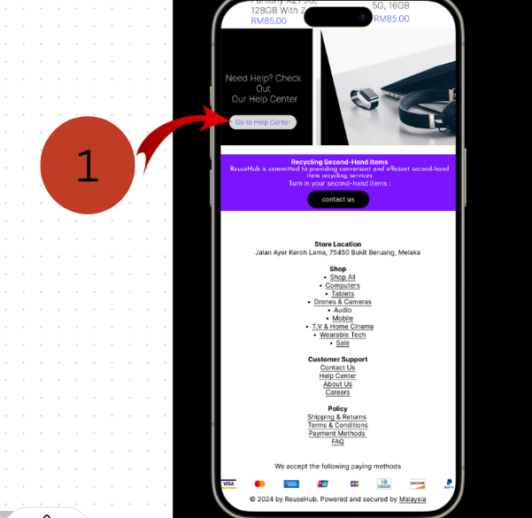

1.Users can access the help center directly by clicking the button displayed on the screen.

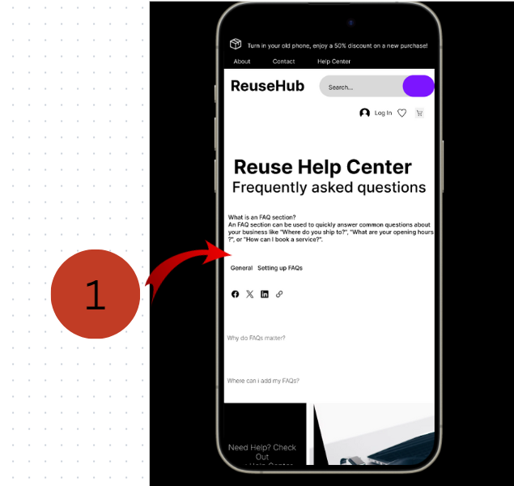

1.Users can add their question and ask us directly through our FAQ section.

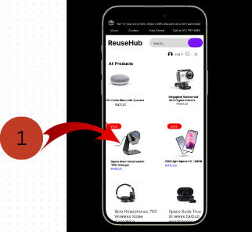

1.Users can conveniently purchase an item by clicking either on the image of the product or its listed price.

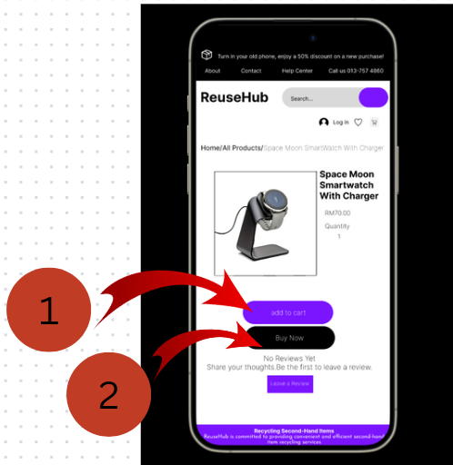

1.Users have the option to either add the item to their cart first or proceed directly to purchase.

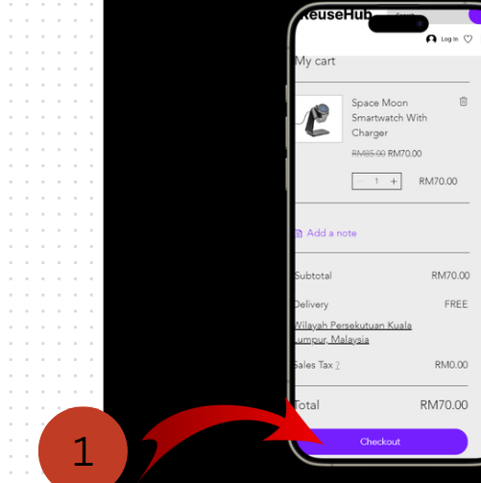

1.Users can easily view their cart to review items and proceed to check out.

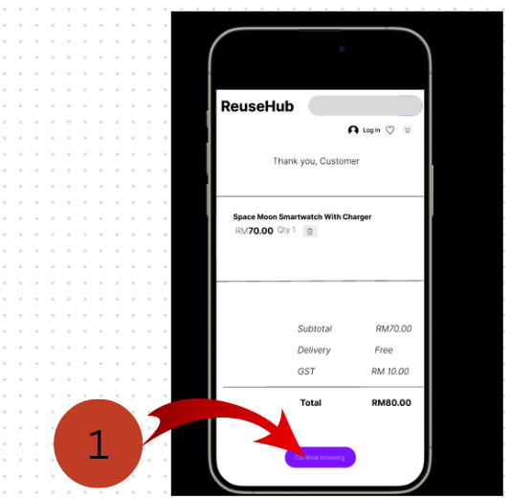

1.After making a purchase, users can easily navigate back to browse our range of products.

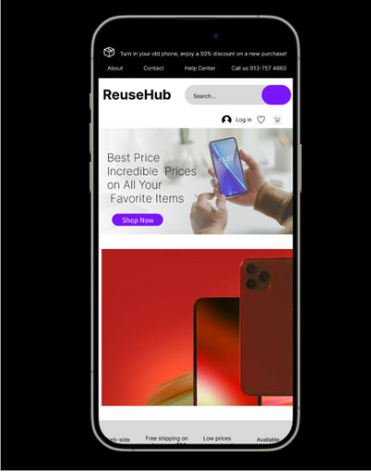

1.

Ifgdskfgsdakjfhgaskdjhfgaskdfjghaksdjhfgaskdjhfgaksjhdgfkasjhdgfkajhsdgfkasjdhfgaskdjhfgasdf‘sjalkdgflaskdjhfgasdlkfjhgasdlkfhgasfdkhgalsdjhkfggasdkhjfgasdhfjgasdhkjfgasdkfjhagsdfkjhasgdfa’